­­Introduction to Scratch

Visual Programming

# Introduction

This tutorial is a quick introduction to Scratch – a visual programming language that can be used to build interactive stories, games and animations.

# Acknowledgements

This tutorial has been adapted using content from the *Getting Started with Scratch Guide* created by the Lifelong Kindergarten Group available here:

<https://scratch.mit.edu/scratchr2/static/__1371843055__/pdfs/help/ScratchGetStarted_beta_draft_Jan2013.pdf>

# Getting Started

Scratch will run in most web browsers without installing additional software. This includes browsers such as Internet Explorer, Mozilla Firefox and Google Chrome. Today we’ll be using Mozilla Firefox, which you can open by clicking the Start Menu, going to All Programs then selecting Mozilla Firefox.

The Scratch website is <https://scratch.mit.edu/> Start by opening that in Firefox.

From the website you can open the Scratch Editor (by clicking *Create*), see programs that students all over the world have created (by clicking *Explore*), or view the Scratch discussion boards (by clicking *Discuss*).

You do not need to register for an account on the Scratch website to complete this tutorial. If you would like to save the project so that you can work on it from home later on or to share it with others, then you will have to register an account with Scratch. You can register a Scratch account by clicking *Join* Scratch on the homepage, or by clicking *Sign in* then *Or Join Scratch* when in the Scratch Editor.

When you’re ready to start making a visual program, click *Create* to open the Scratch Editor. You should see something like the image below:

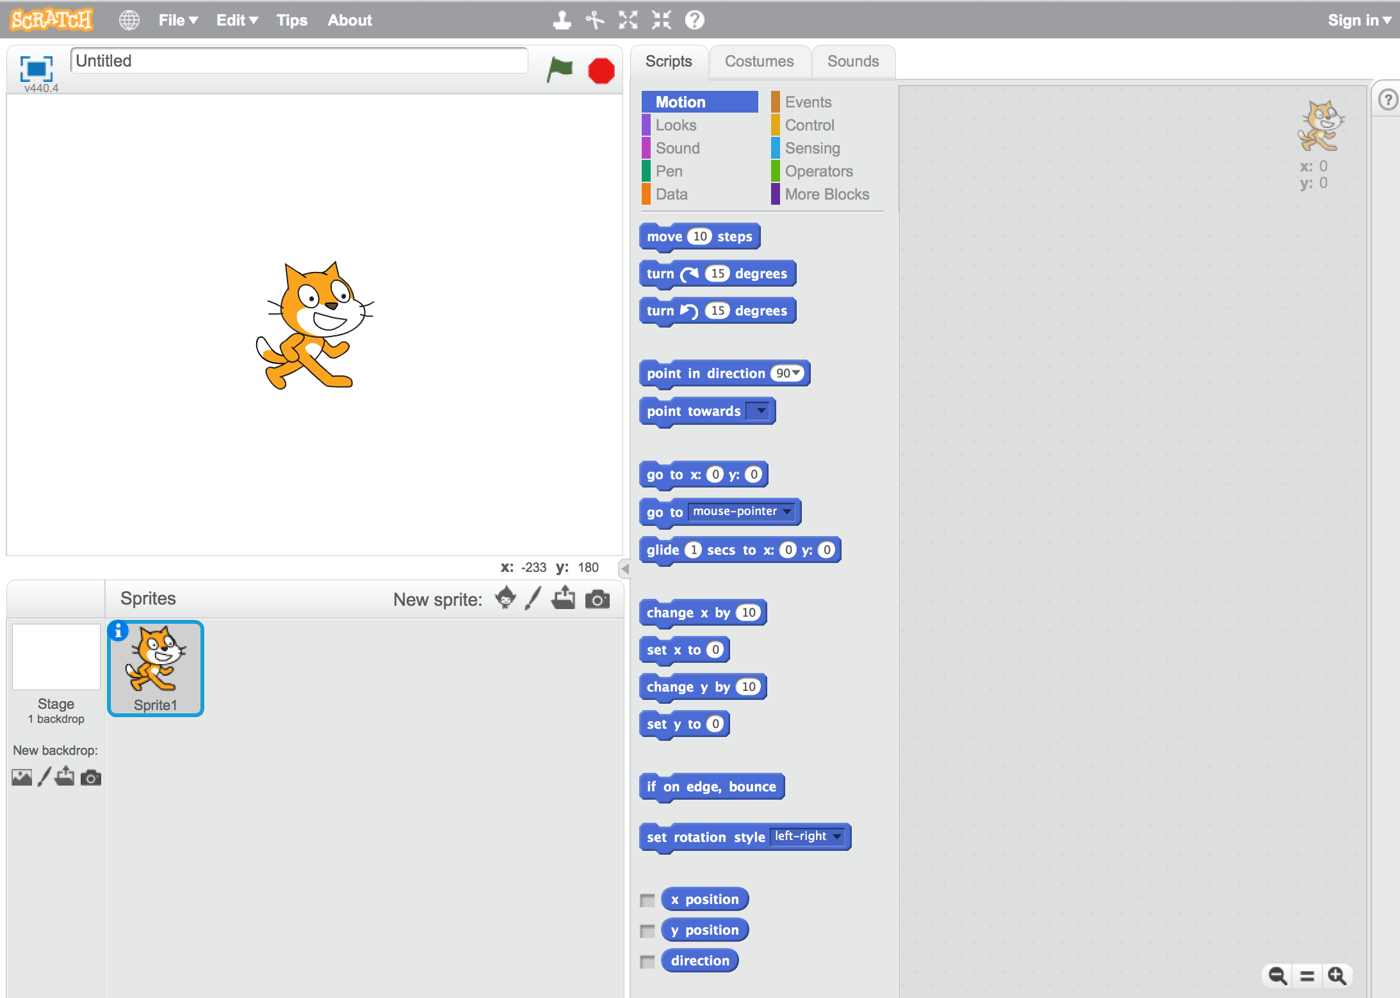

# Start Moving

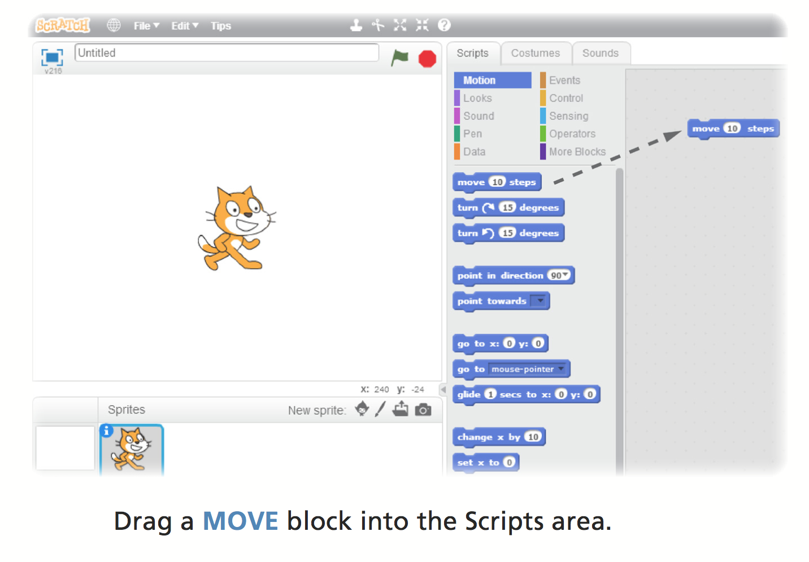

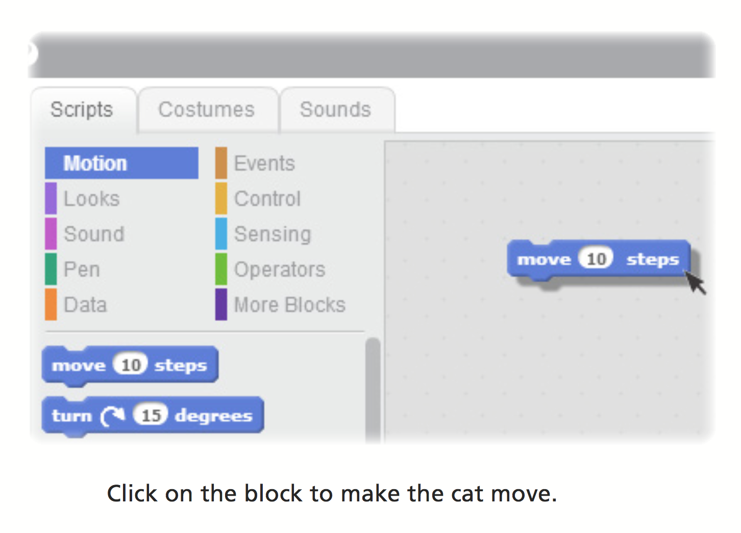

# Add a Sound

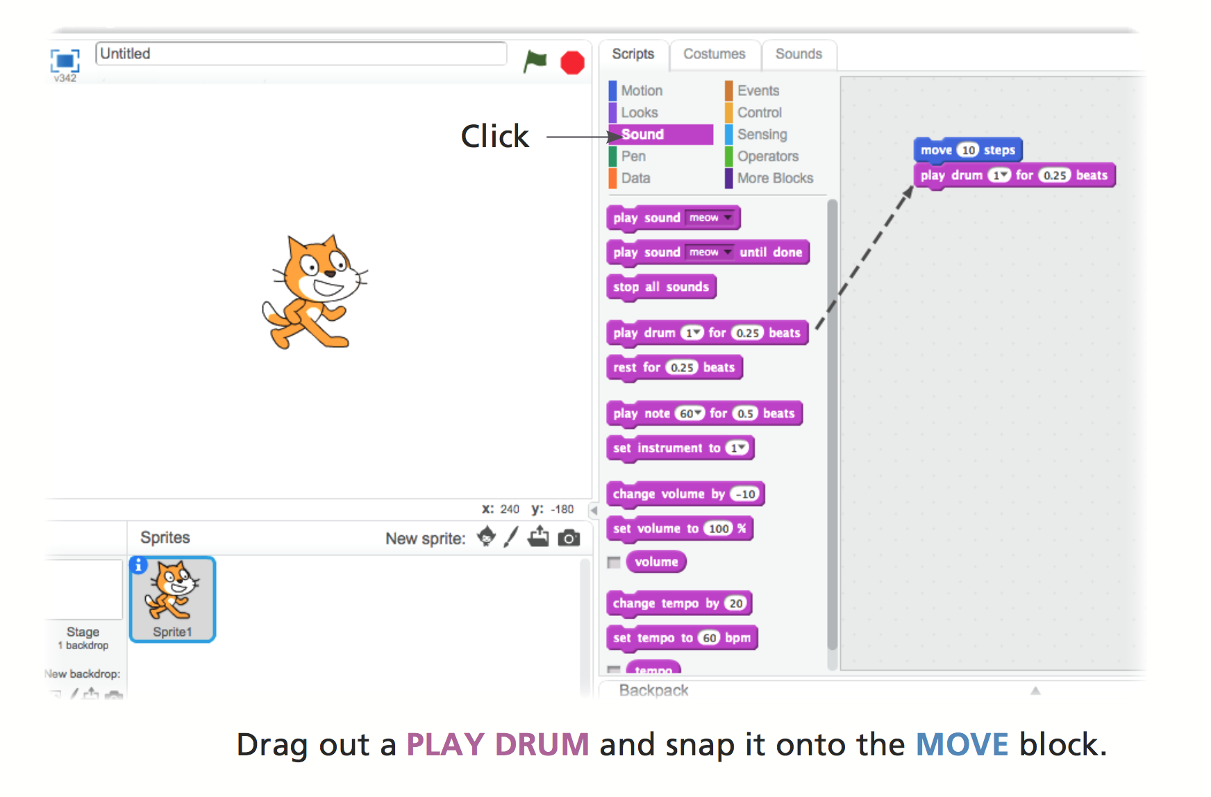

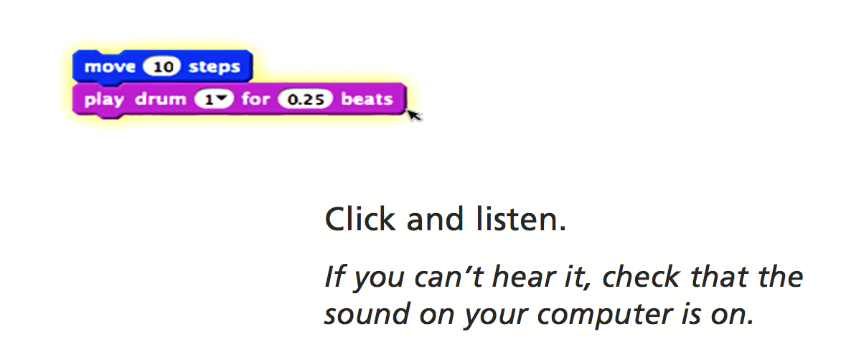

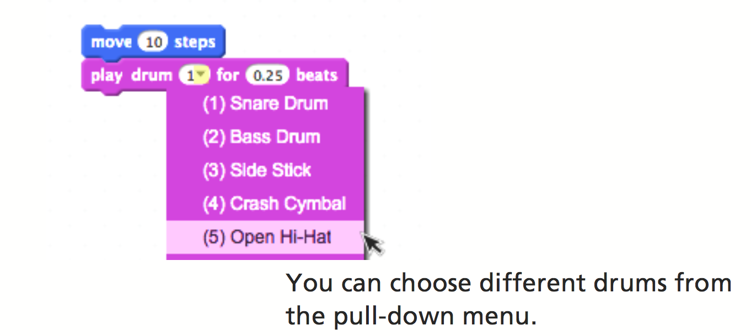

# Start a Dance

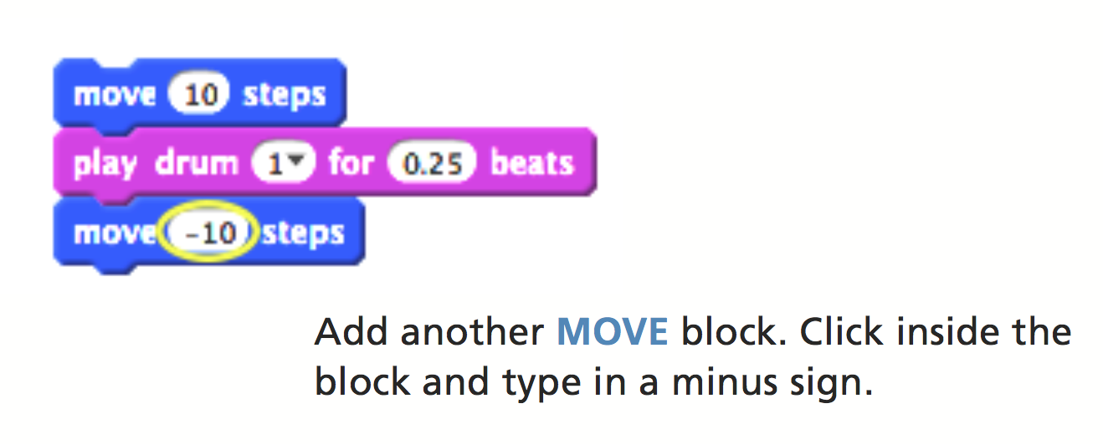

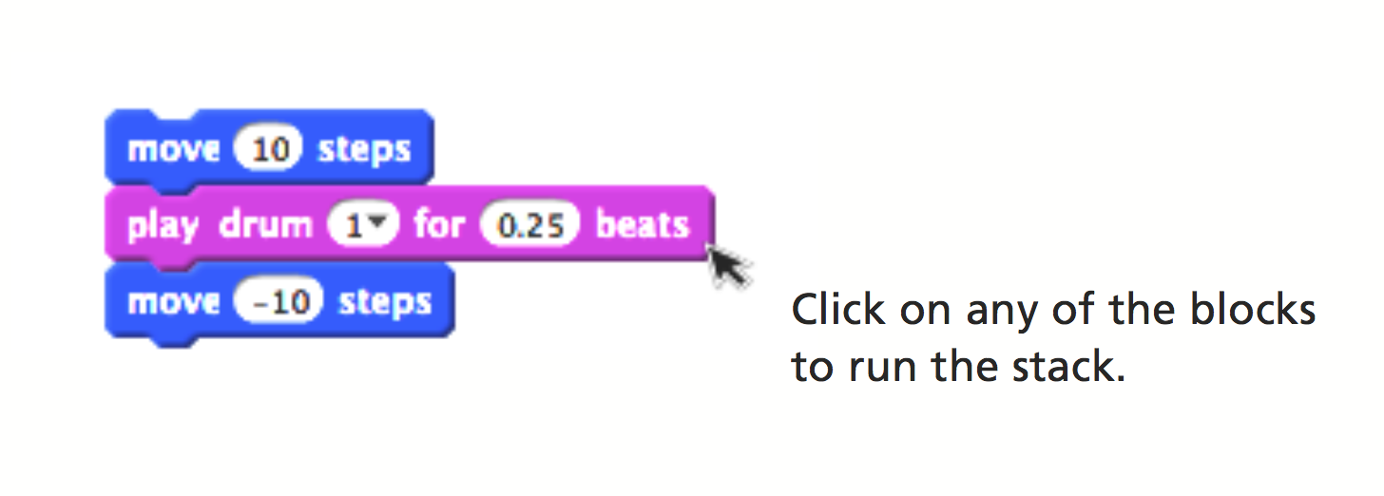

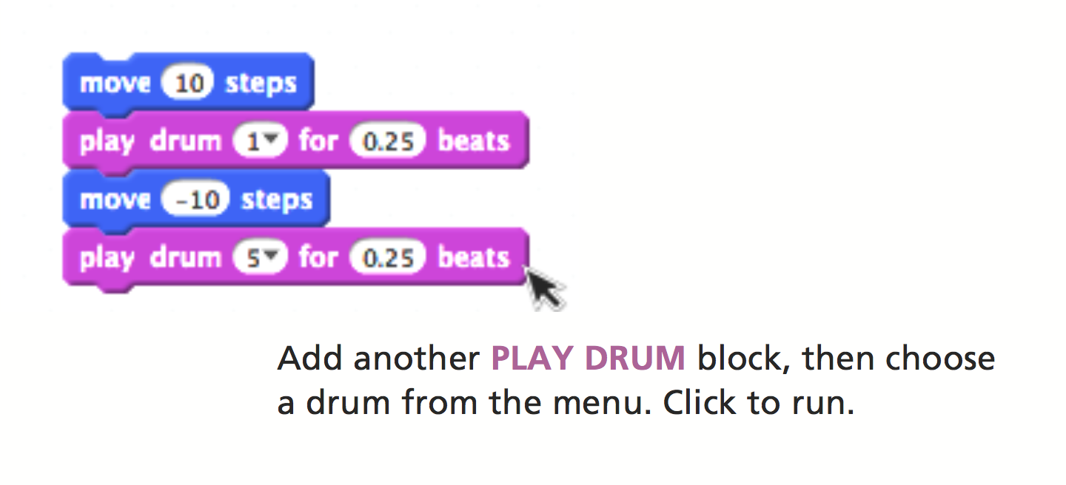

# Again and Again

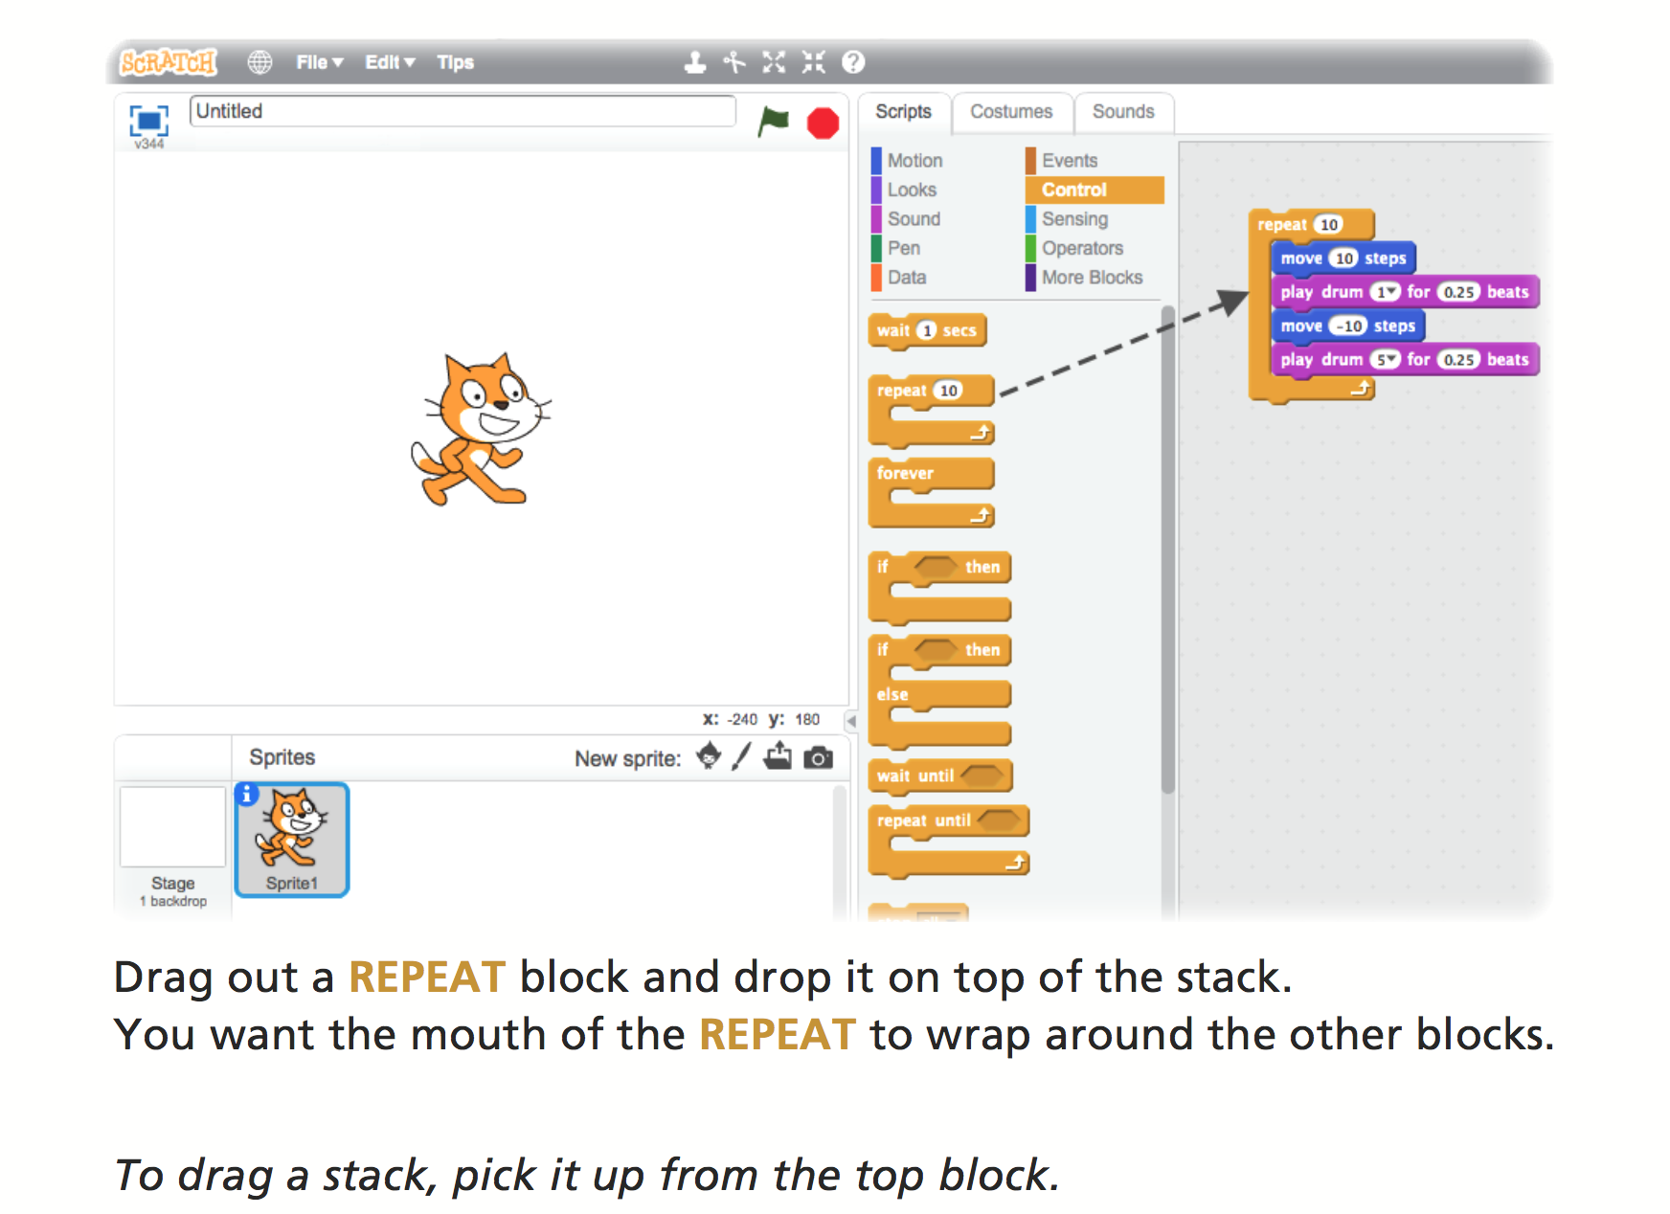

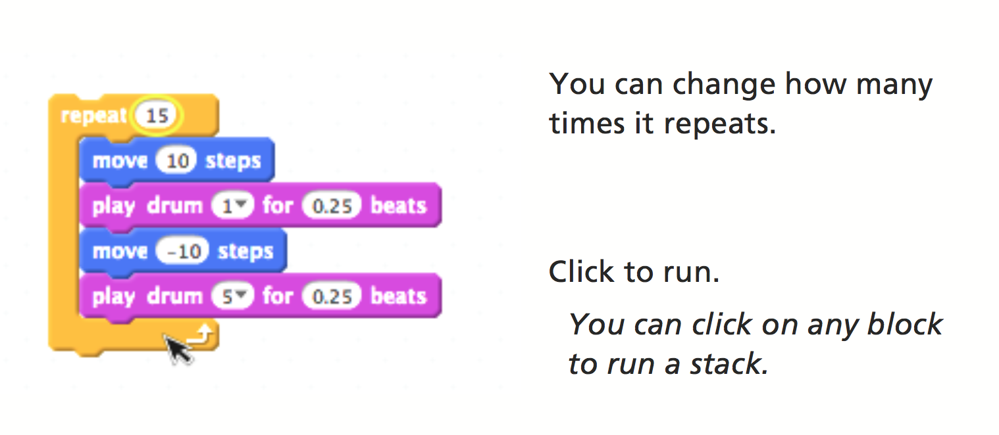

# Say Something

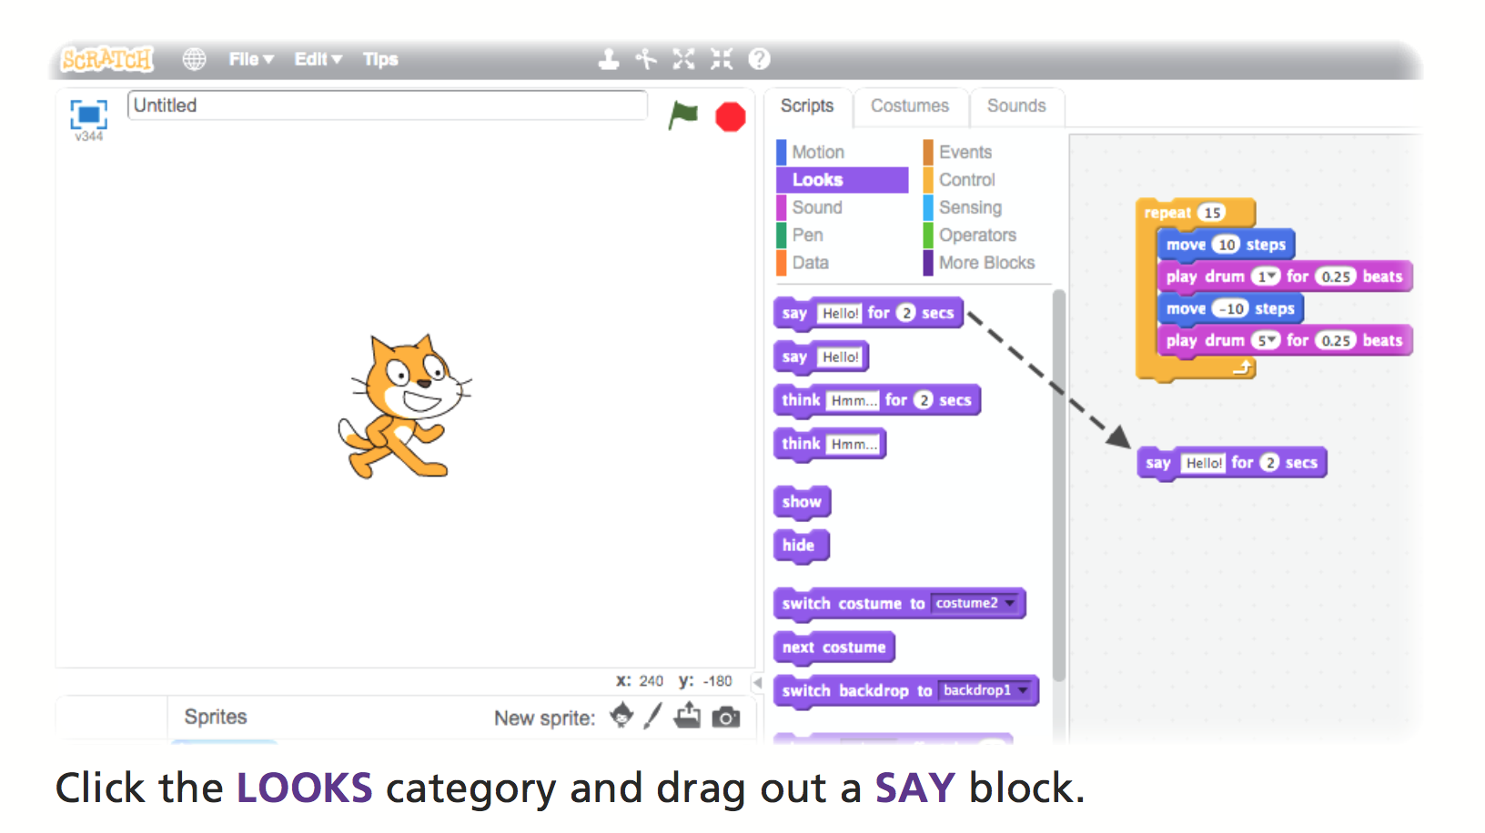

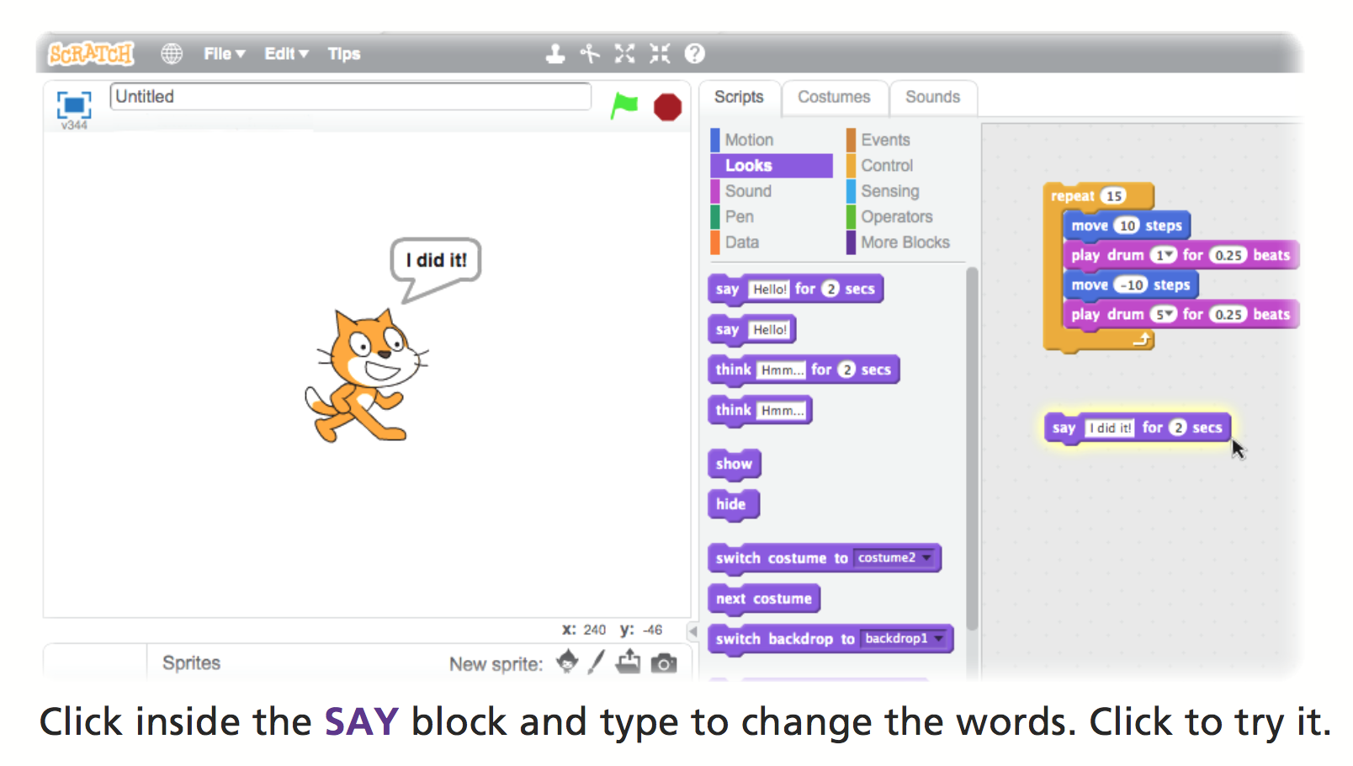

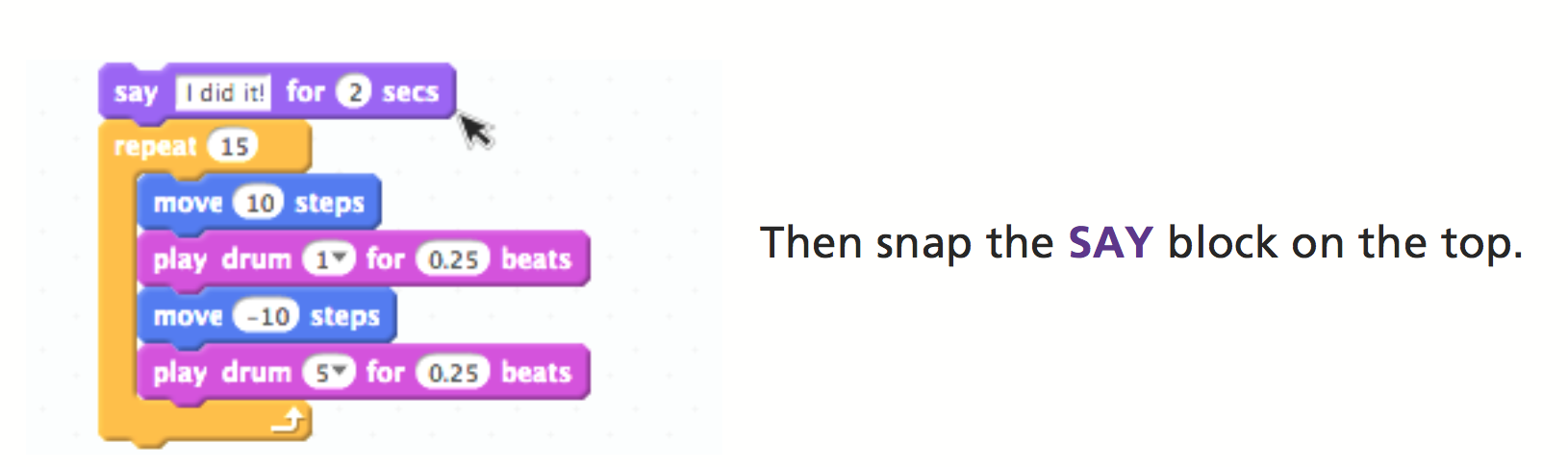

# Green Flag

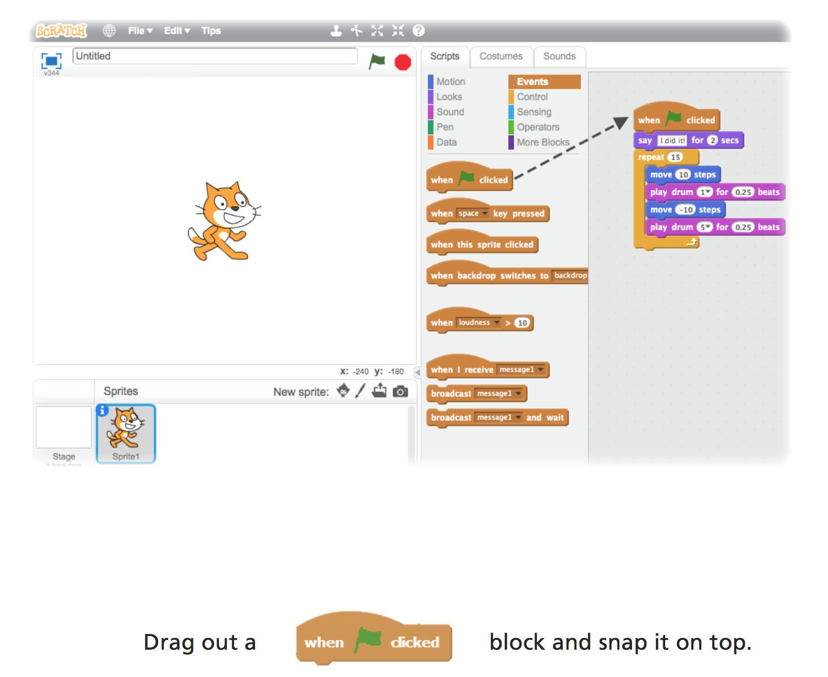

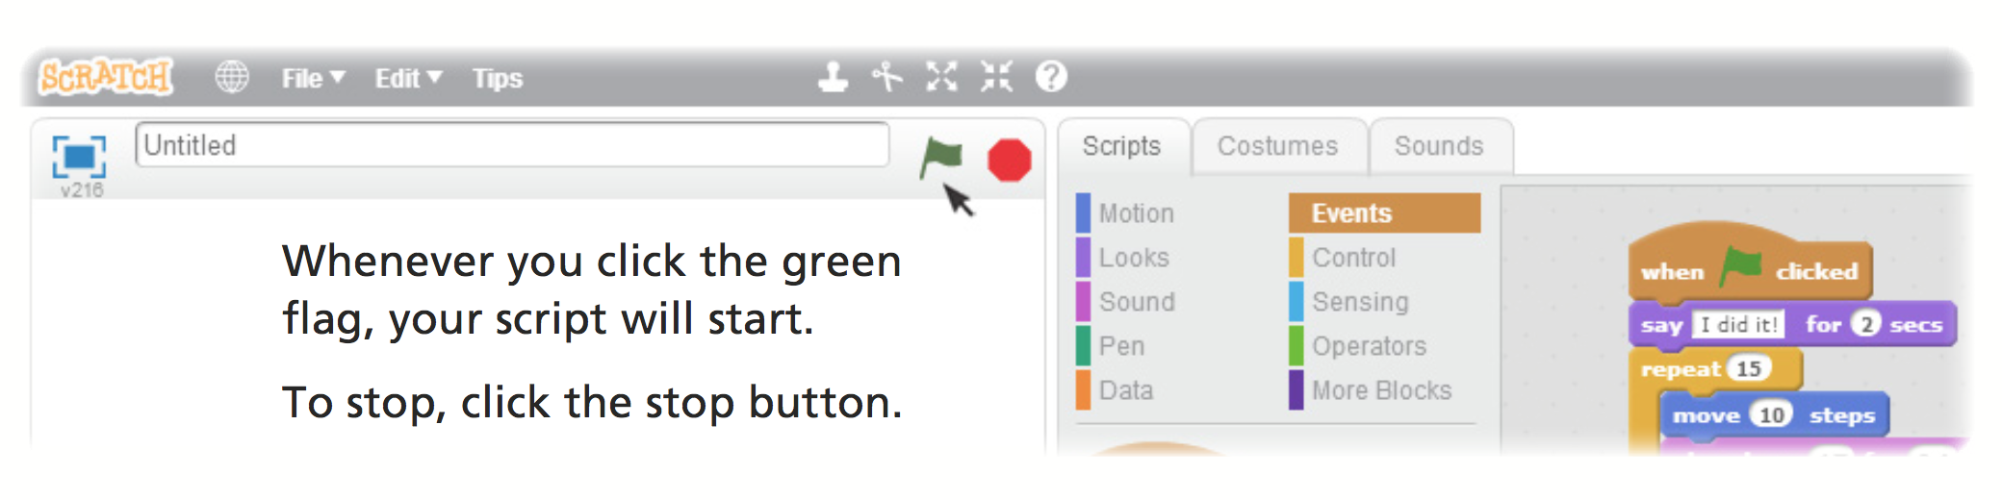

# Change Colour

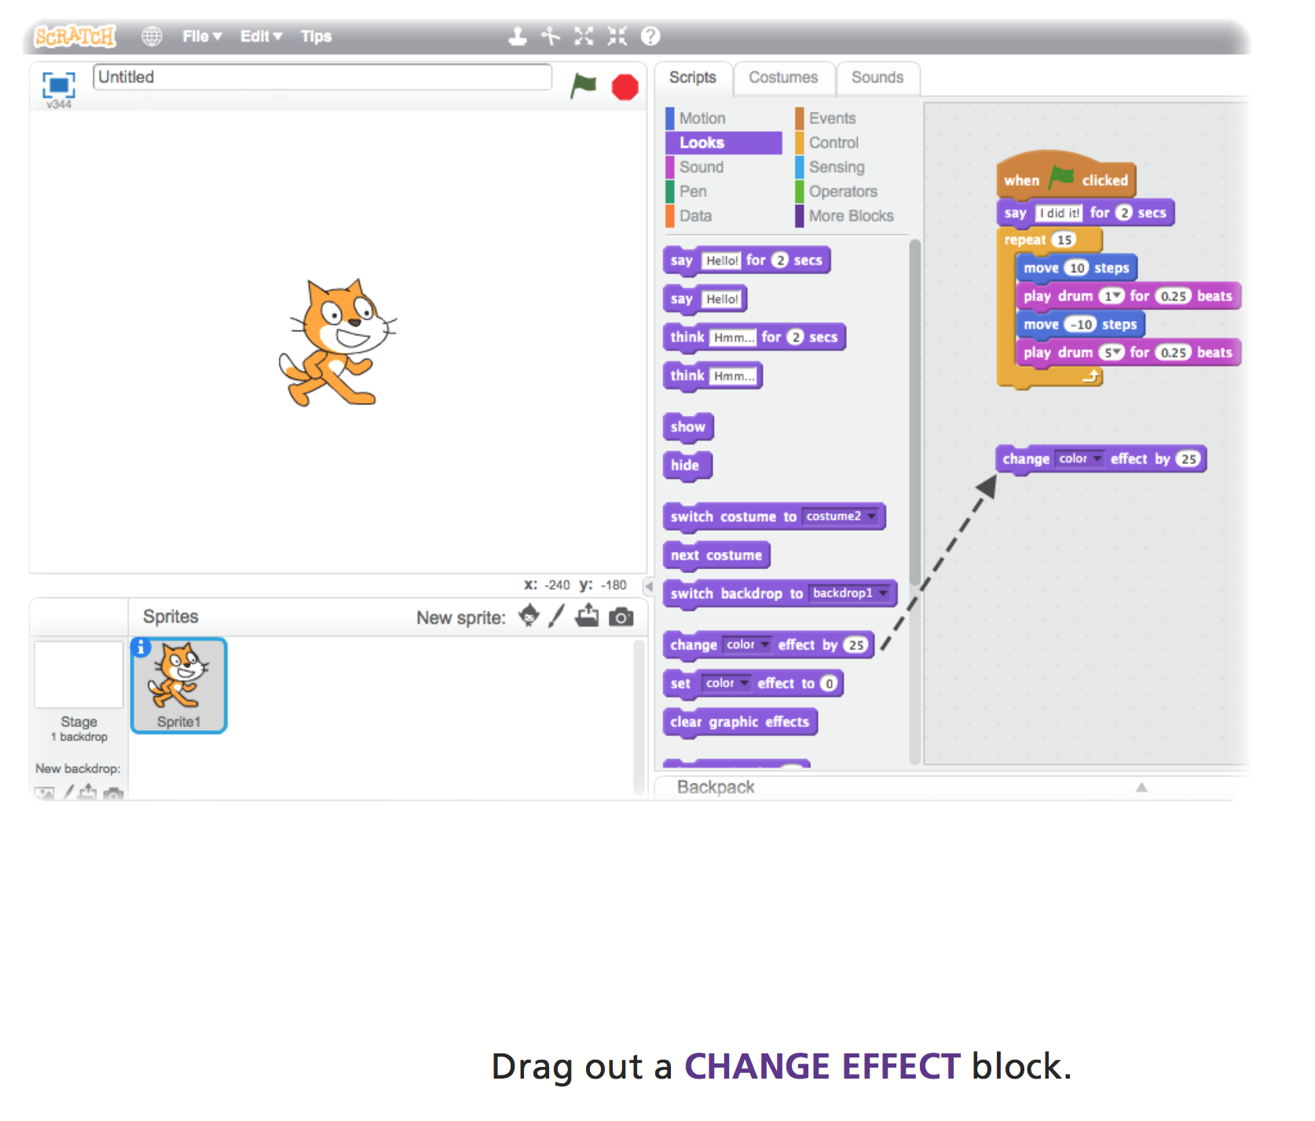

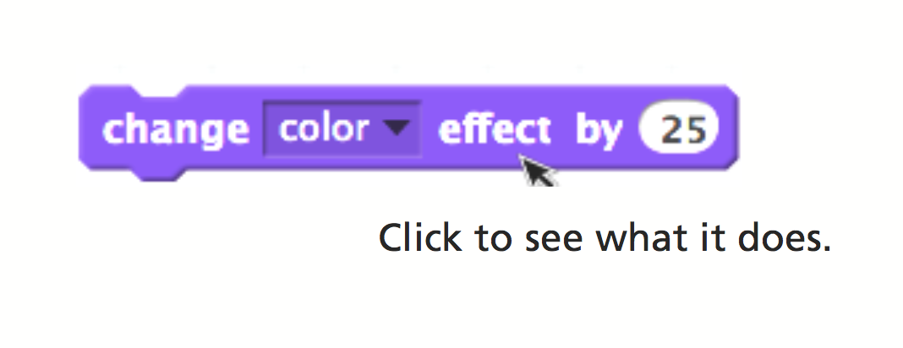

# Key Press

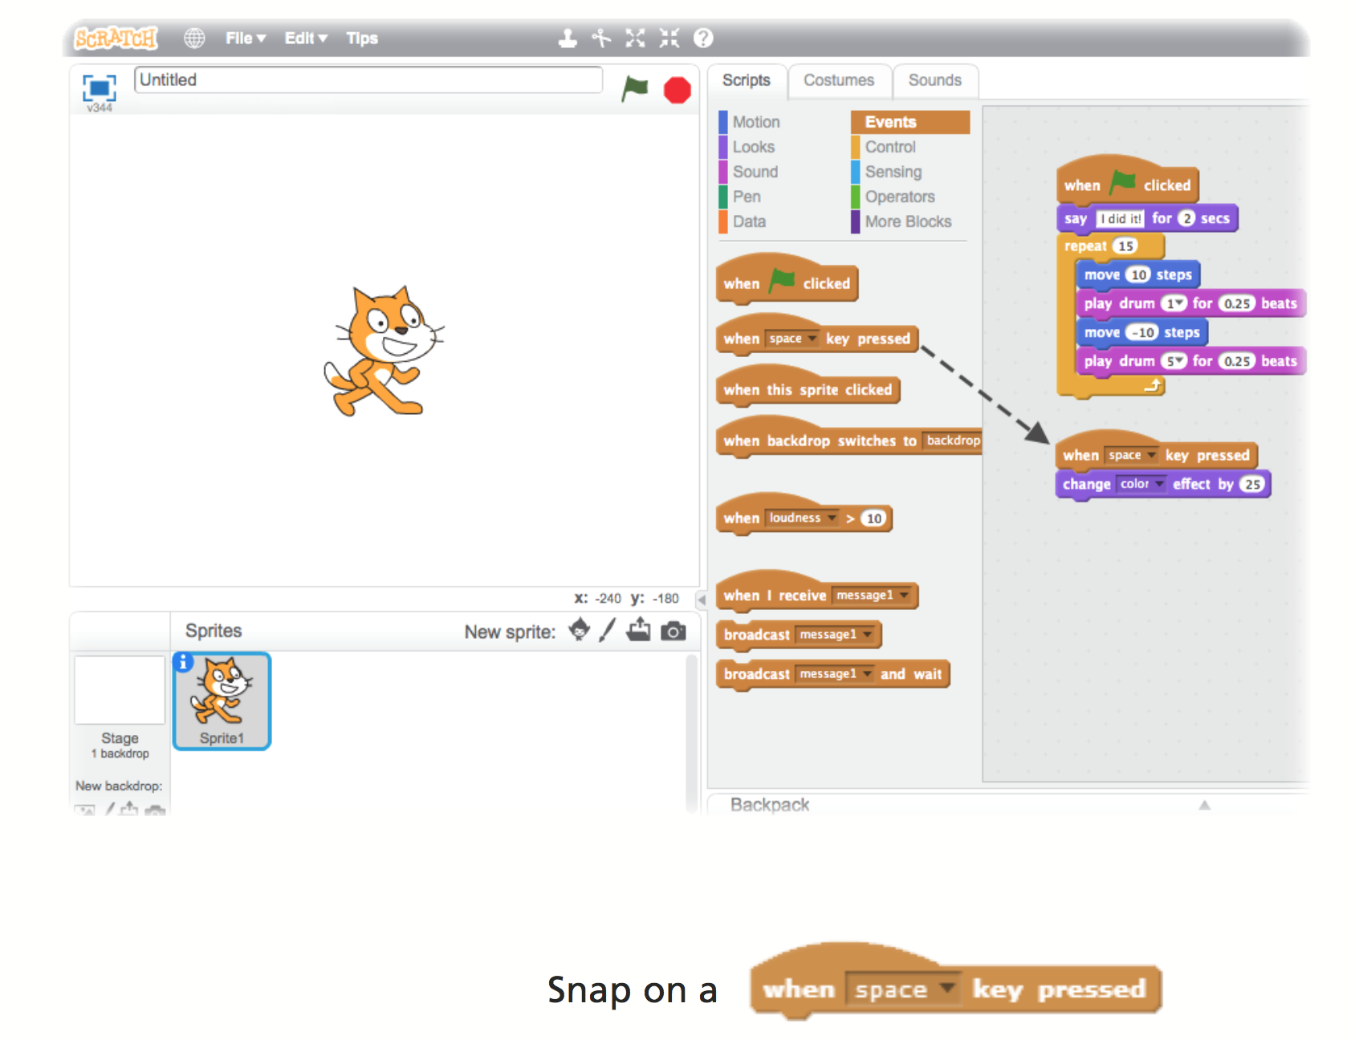

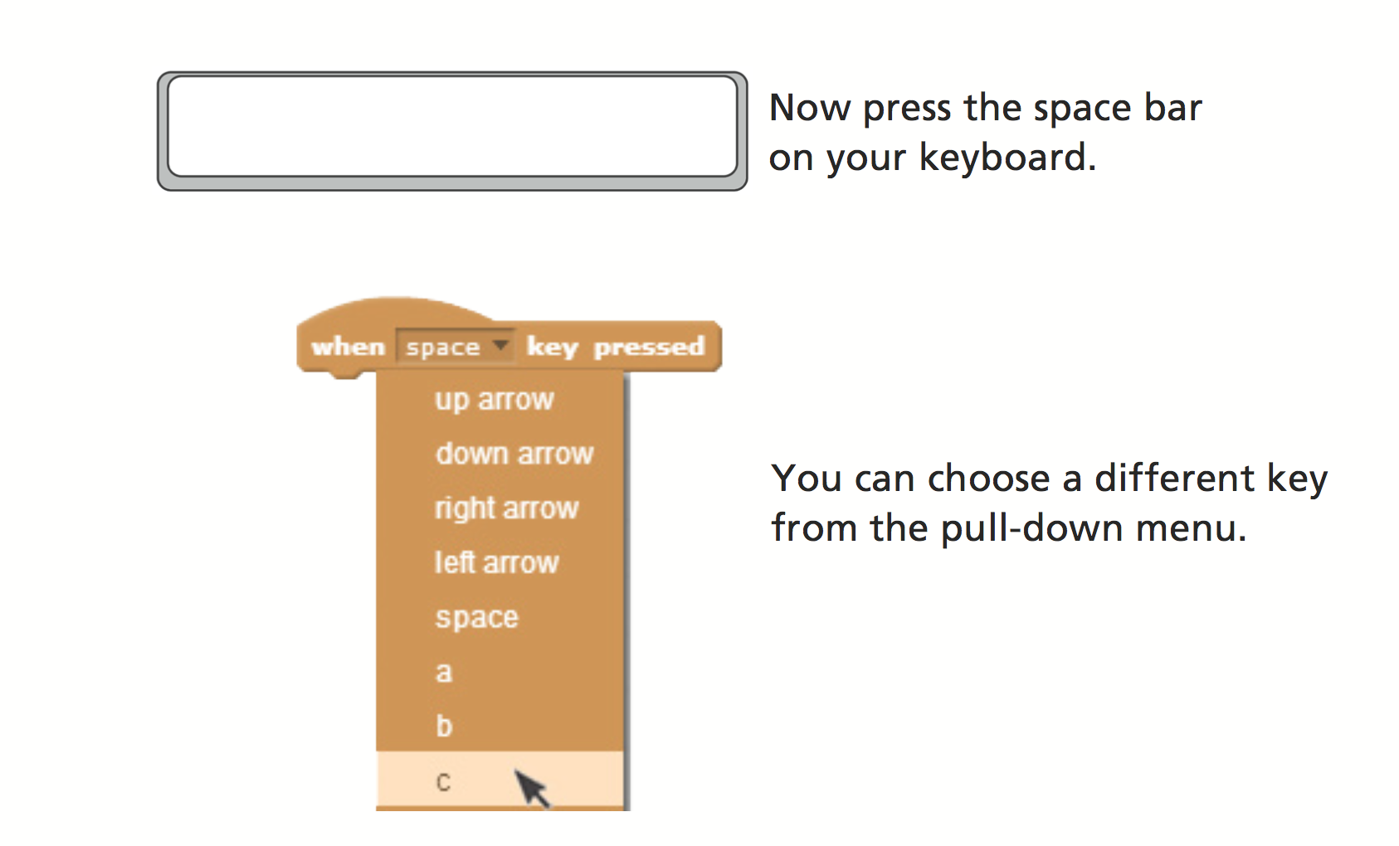

# Add a Backdrop

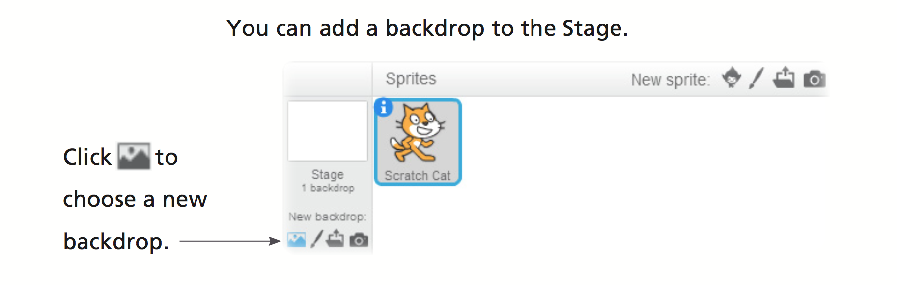

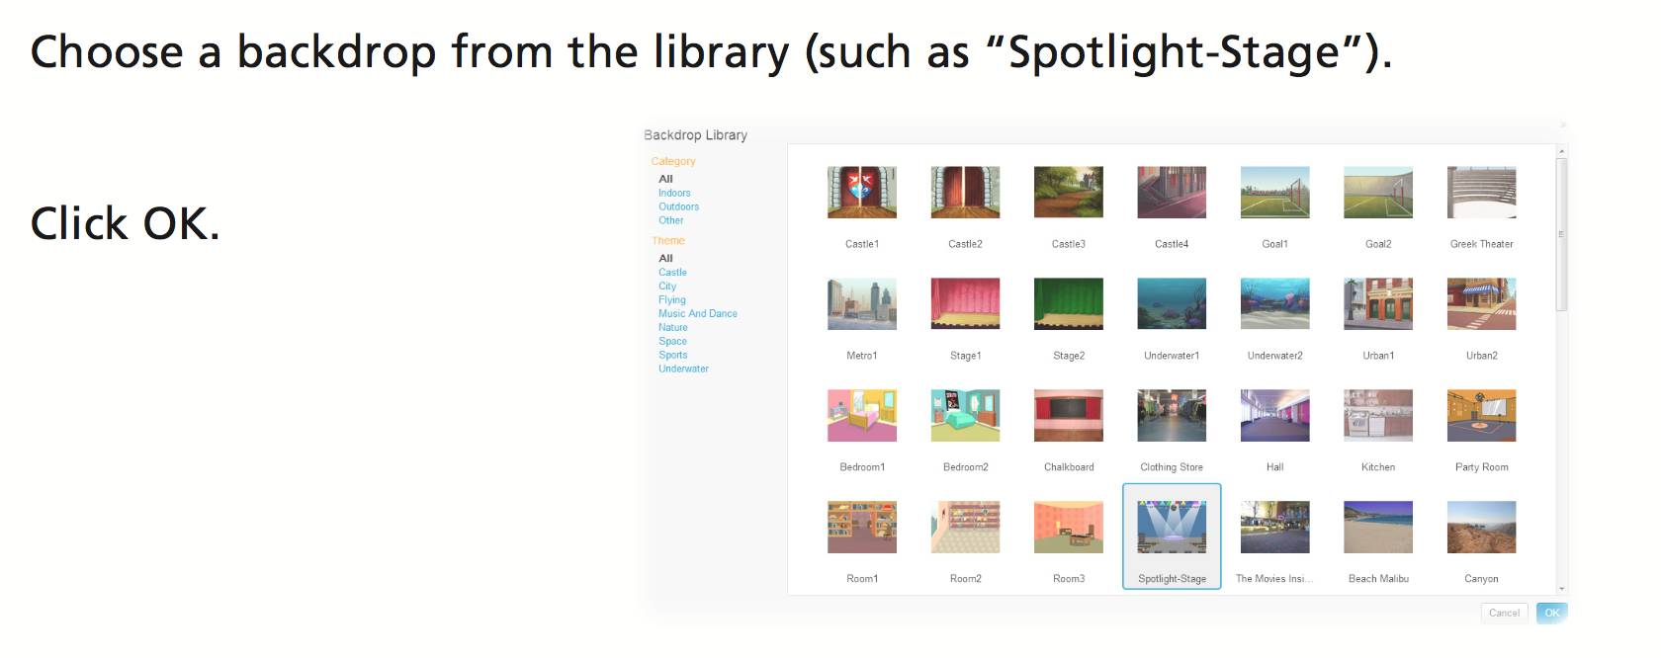

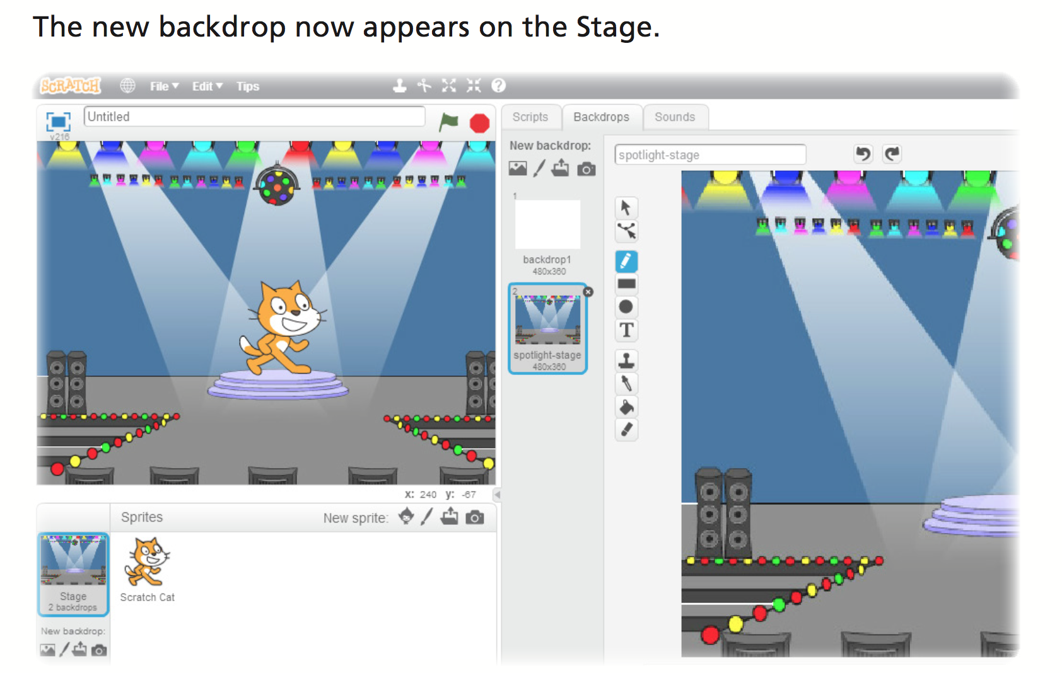

# Add a Sprite





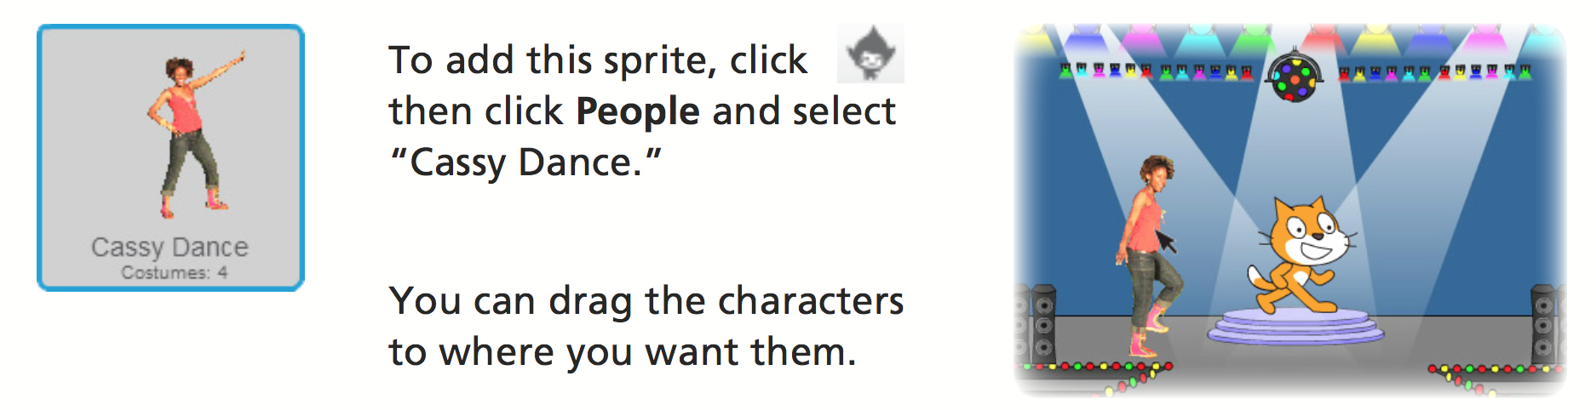

# Animating

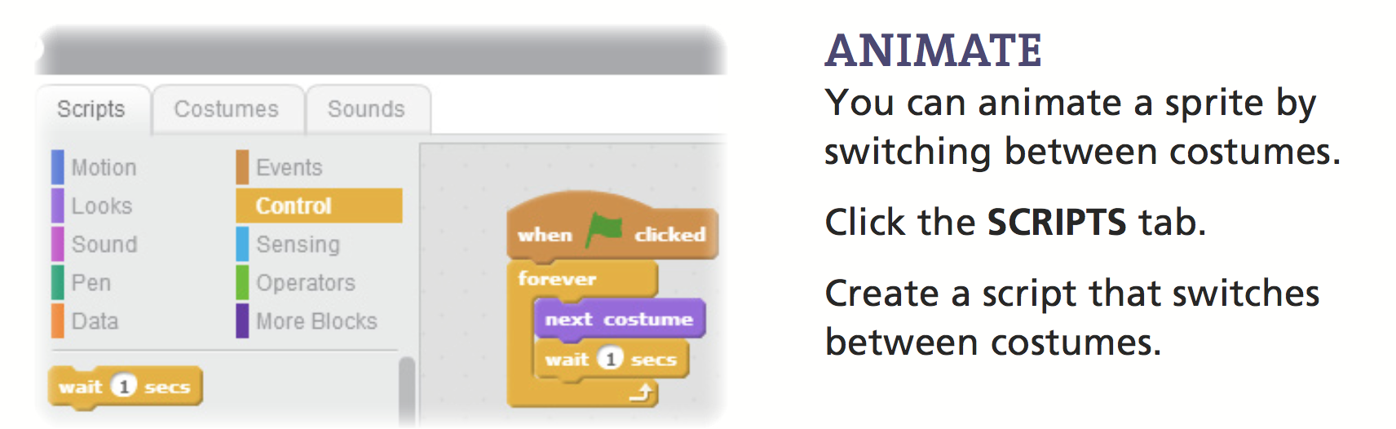

Good work, you have completed the Introduction to Scratch tutorial!